**Machine Learning Pipelines A-Z | Day 29 | 100 Days of Machine Learning**

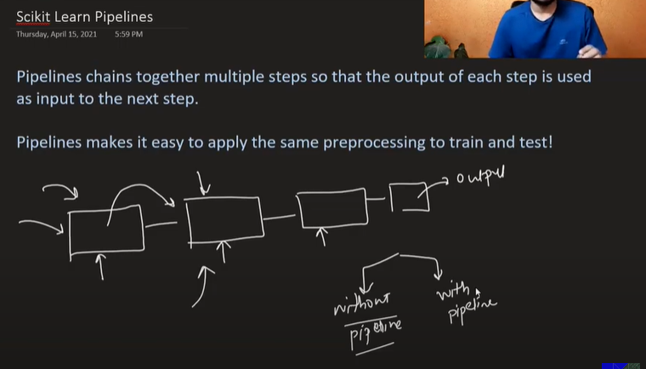

In Scikit Learn Pipelines we can holistically build a pipeline of set of steps that we regularly perform individually such as imputing null values, encoding and training the model

# Function Transformer | Log Transform | Reciprocal Transform | Square Root Transform

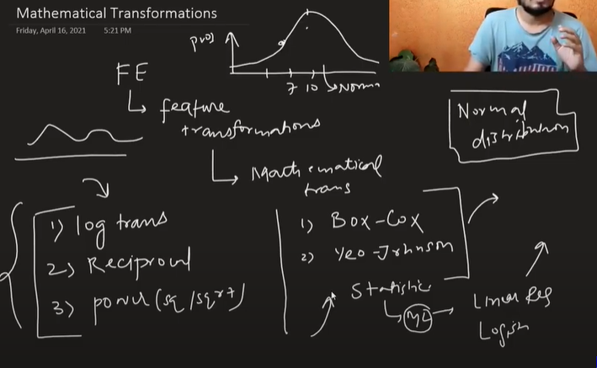

These Feature transformations are used to transform data to normal distribution. Statistical models such as Linear Regression and Logistic Regression demands the normal distribution and hence these feature transformation converts any kind of distribution into normal distribution

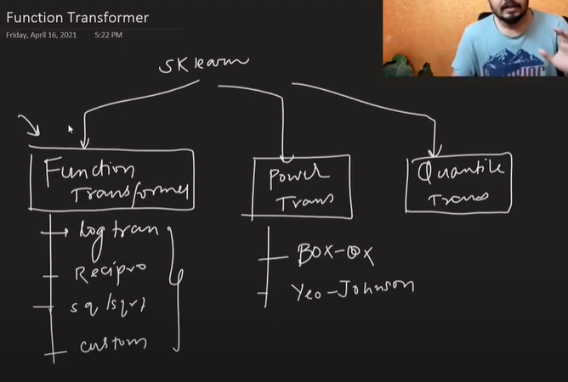

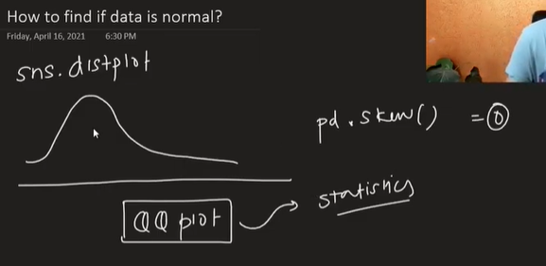

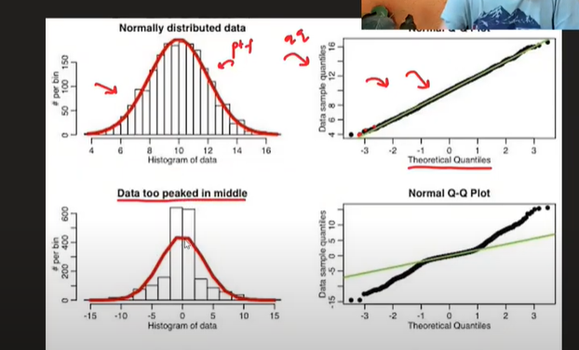

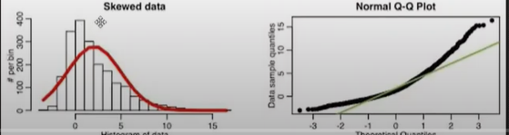

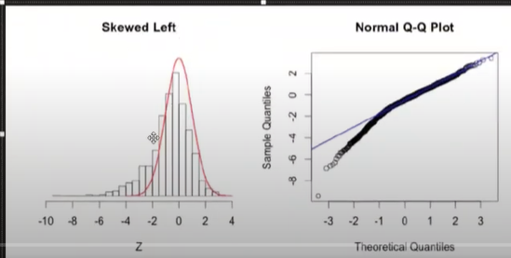

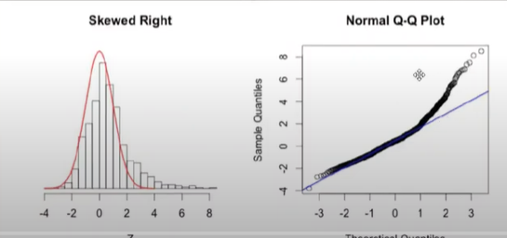

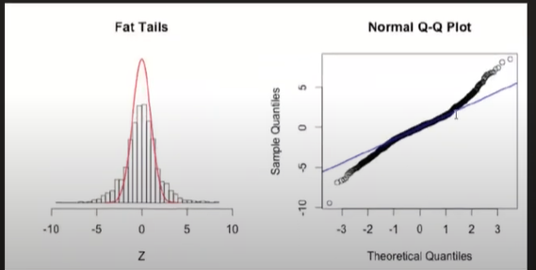

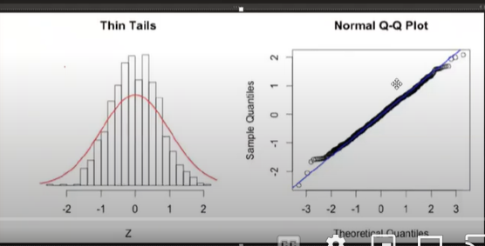

**Log Transformer**

It converts the bigger scales into smaller linear scales in equidistance

It cannot be applied on the negative values but it is useful in the right skewed data

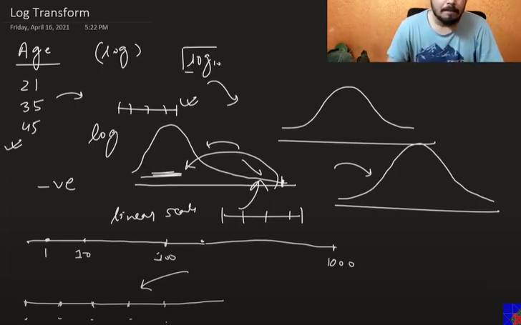

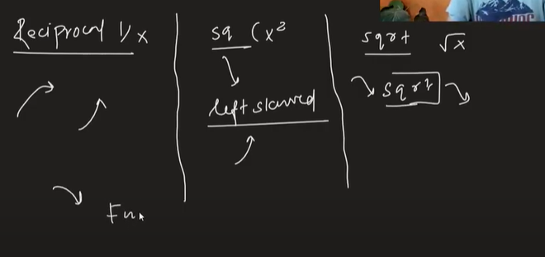

Square transform is used in case of left skewed data

Difference b/w np.log and np.log1p is that 1p adds 1 and then applies log, while the dataset has some zeros we use 1p else we use np.log

Applying log transformation to normally distributed data leads to less accuracy while it doesn’t change results that much if we apply it to tree based models

It gives better results in Linear/ Logistic Regression models

# Power Transformer | Box - Cox Transform | Yeo - Johnson Transform

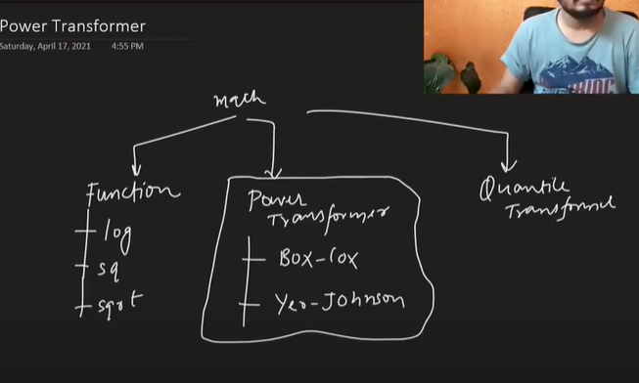

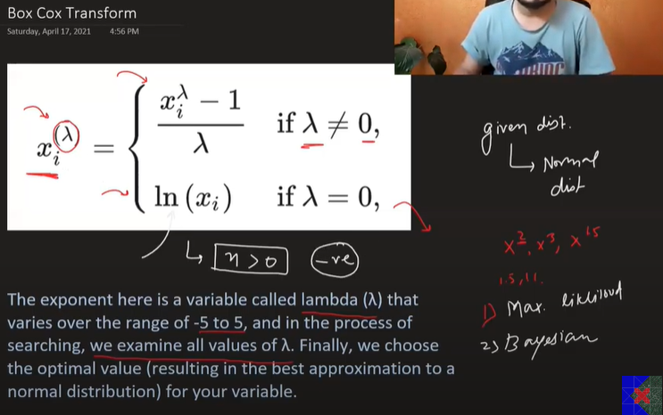

Box cox transformation doesn’t work on zero and negative values

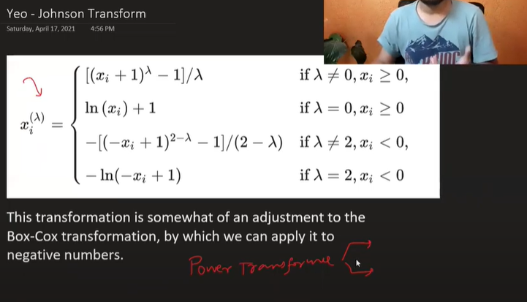

Lambda value is calculated using maximum likelihood or Bayesian stats

We don’t need to apply standardization separately while applying PowerTransformer()

When we are using box-cox transformation, if the values are zero it won’t work. So we add 0.00001 to avoid these scenarios

# Binning and Binarization | Discretization | Quantile Binning | KMeans Binning

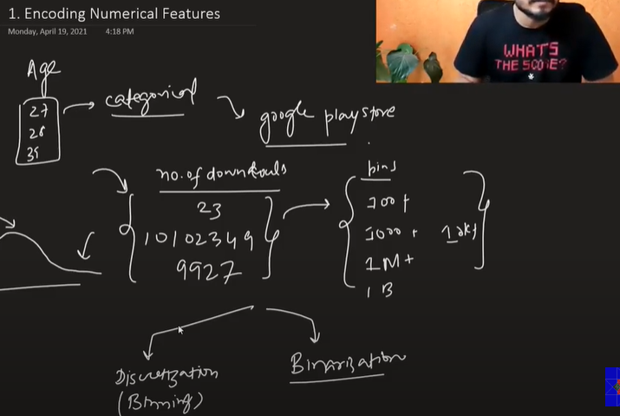

Now in some scenarios encoding the numerical values can do the trick

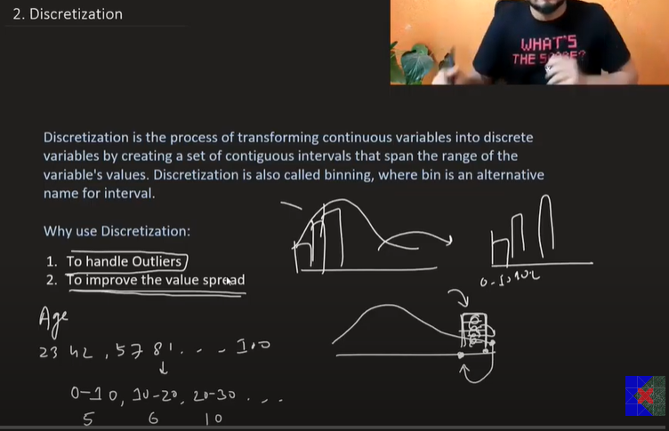

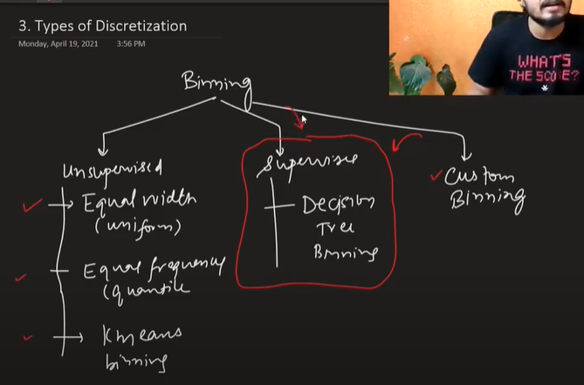

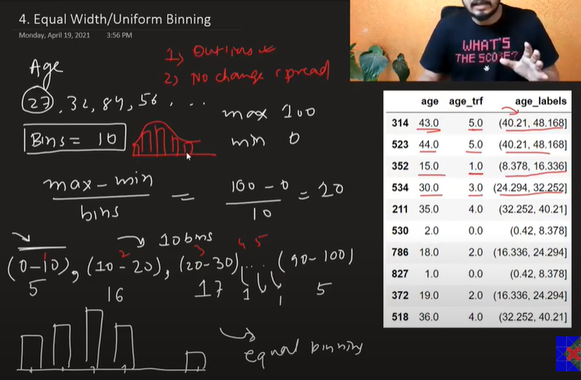

Equal width/ Uniform binning helps to handle outliers and there is no change in the spread

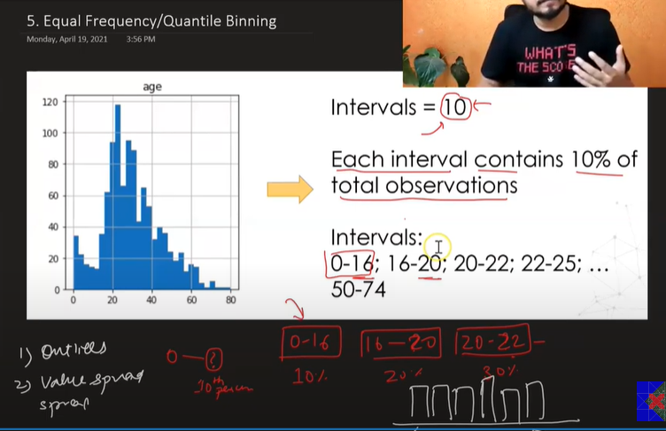

In this type of binning, the bin size may not be equal but each bins stores 10 percentile data. So 10 intervals will score 100 percentile data

This is also robust to the outliers and the makes the spread uniform

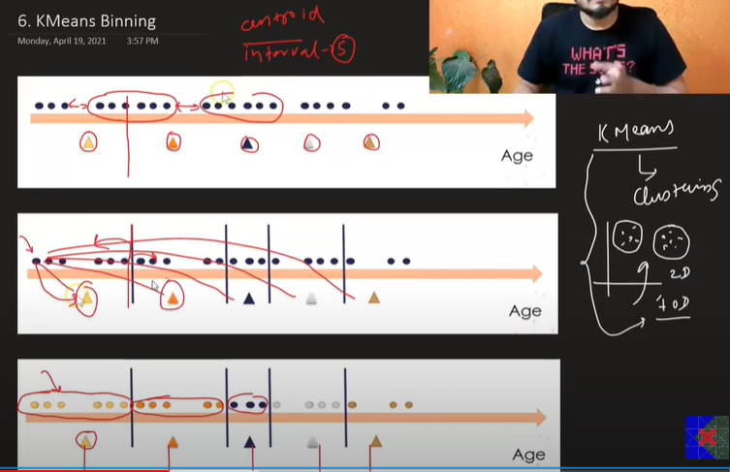

This type of binning is used in scenarios where the data is in clusters

We define centroid and calculated distance of all the points from each centroid. The point which is closer to the respective centroid is considered and that point is mapped in same cluster

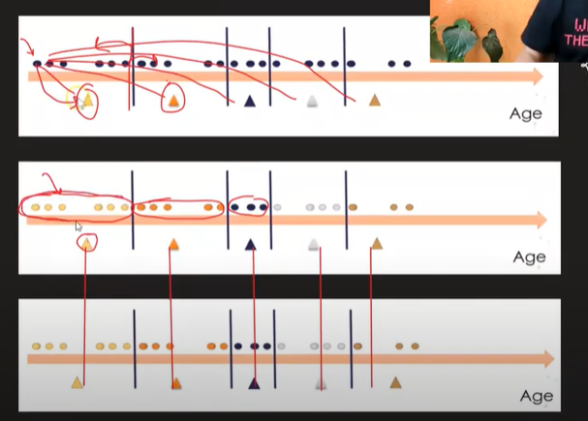

Now when all the clusters are formed, we take the mean of all the points in the clusters. After calculating the mean, we shift the centroid to the position of mean of respective cluster

Now, we perform the same steps of clustering and shifting the centroids until when the difference b/w the original position and the new position is the same

The final position of centroid is the bins and intervals

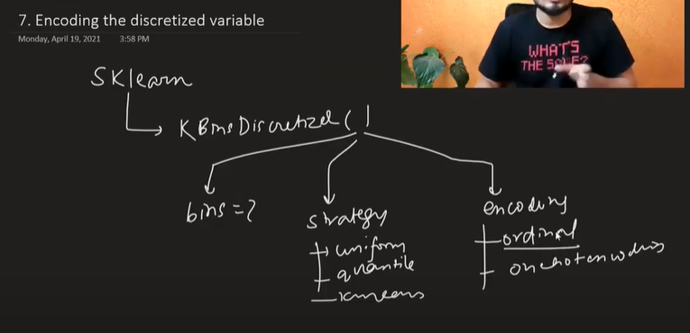

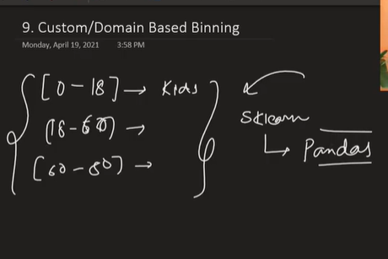

Custom/Domain Binning is performed manually based on domain expertise. We can use pandas pd.cut for this

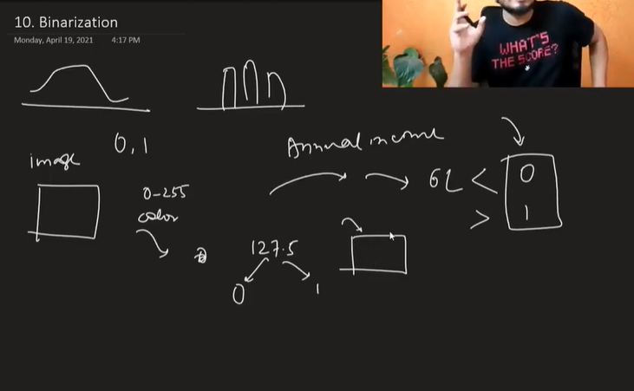

In Binarization, we split the continuous values into either 0 or 1

It is mostly used in image processing

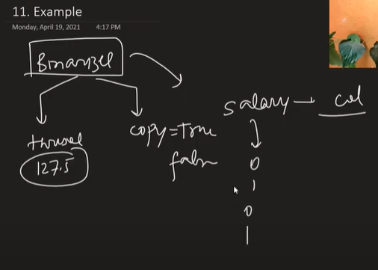

# Handling Mixed Variables | Feature Engineering

Handling a column that contains mixed datatype values can be a challenge. If there are such scenarios, we split the column into two separate columns

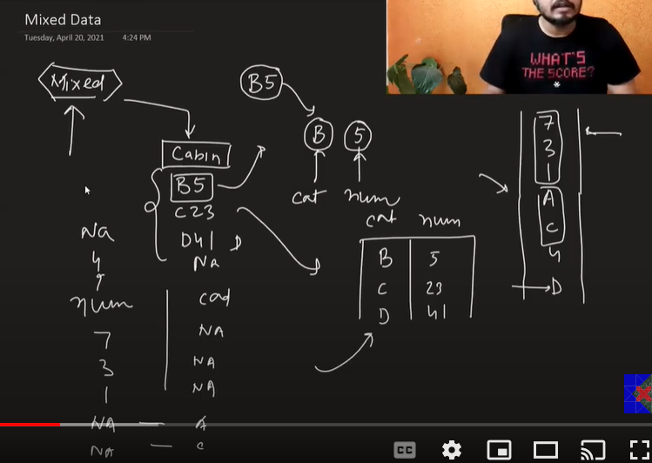

# Support Vector Machines | Geometric Intuition

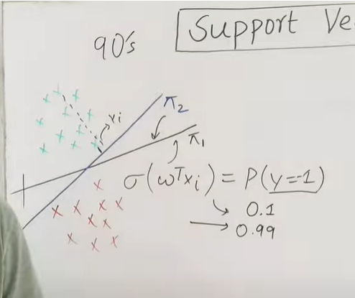

Support vector machine is extension of logistic regression

Suppose there are two lines pi1 and pi2 and they both can 100% correctly classify both classes

Logistic Regression could easily consider either one of them, but not SVM. It will select pi2 as the best hyperplane/line to classify the points

What SVM does is that it wants to create more gap b/w the both classes such that it can accurately classify

So we look for the plane that is maximizing the gap b/w the hyperplane and the classes

SVM tries to maximize the difference b/w two classes using two more hyperplanes

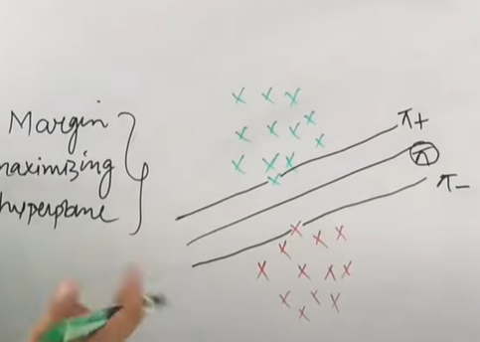

Now we draw two hyperplanes one touching the first point of positive class (pi+) and first point of the negative class (pi-)

Now we find the margin(d), shortest distance b/w pi+ and pi-

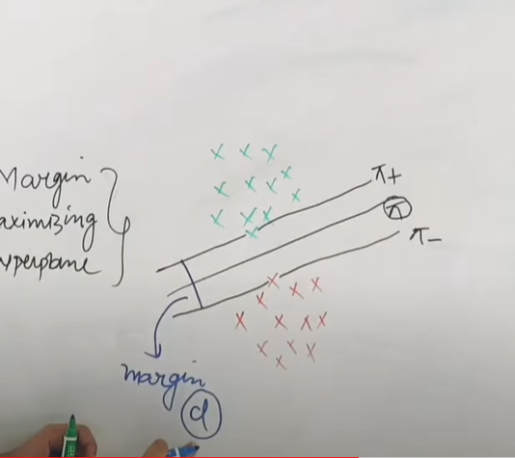

Now, we do this similar steps for bunch of other hyperplanes

Then we select that hyperplane for which the value of d is maximum

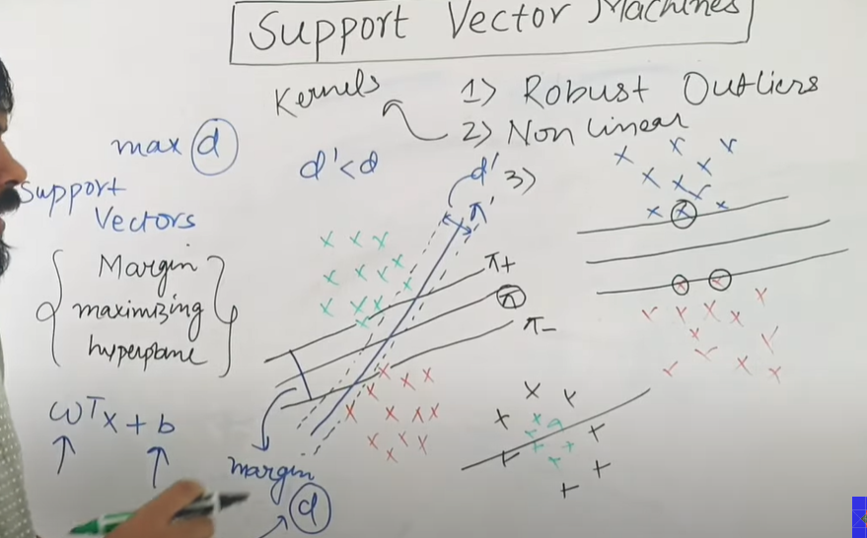

SVM will select line pi over pi’ as d is maximum

The points from each class that are touching the line are known as support vectors

Advantage of support vectors:

1. Robust to outliers
2. Can work on non-linear datasets
3. Can work on both classification and regression problems

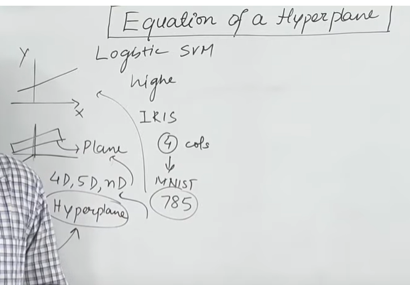

In higher dimensions, line becomes a hyperplane

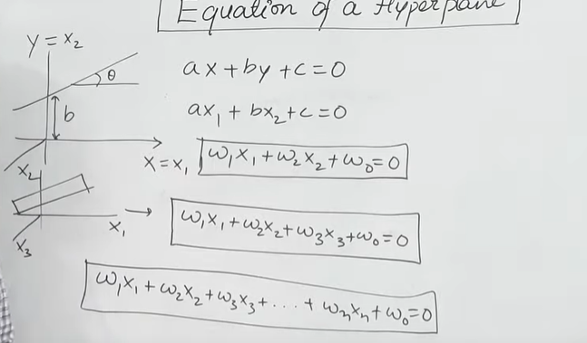

Now we can normalize this equation in terms of vector algebra

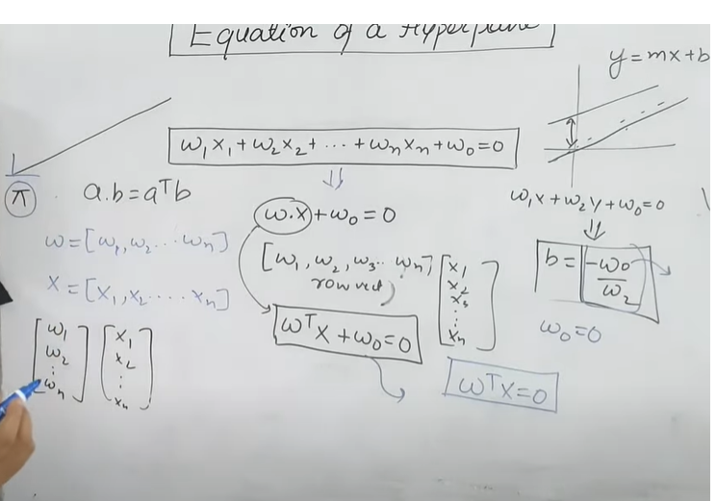

We are assuming that hyperplane is passing through the origin, so intercept coefficient becomes zero (wo)

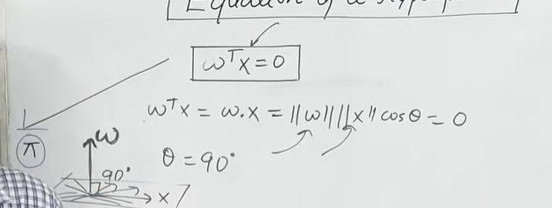

Coefficients are always perpendicular to x (independent features)

# Mathematics of SVM | Support Vector Machines | Hard margin SVM

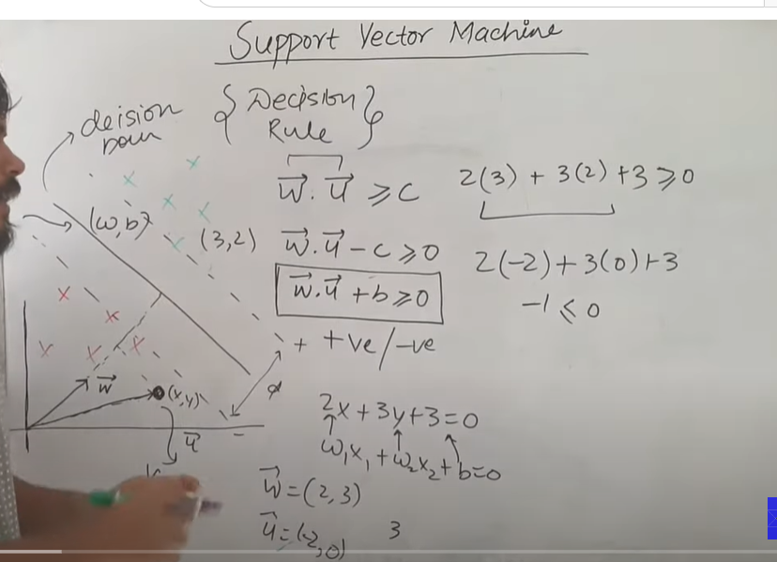

Suppose we know w vector with the coefficients, and we need to classify new points in either positive or negative region. We consider the unit vector (x,y) for the new point to be classified and project it to w vector and then calculate the dot product of u and w vectors ( since we are projecting). If u.w > c (distance from threshold) or u.w +b > 0 then we classify it as positive point and if < 0 then negative point

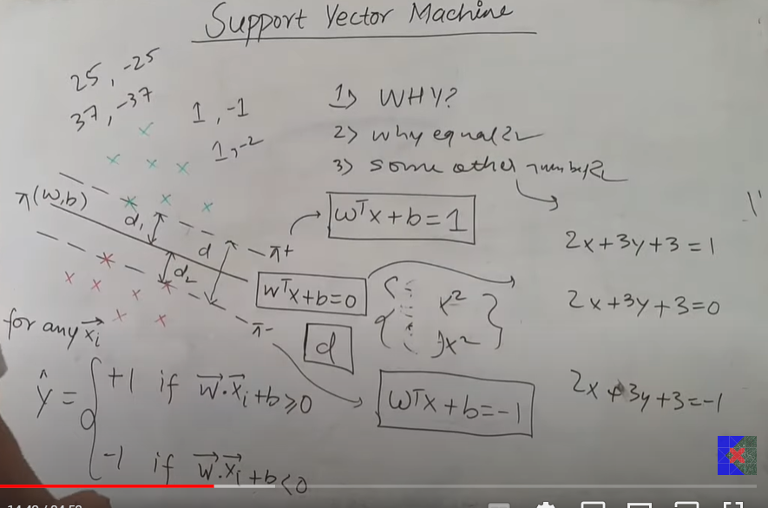

Now our aim is to find the equation of hyperplane, for that we need to find d b/w pi1 and pi2

We have to make sure that pi is at equal distance from pi+ and pi-

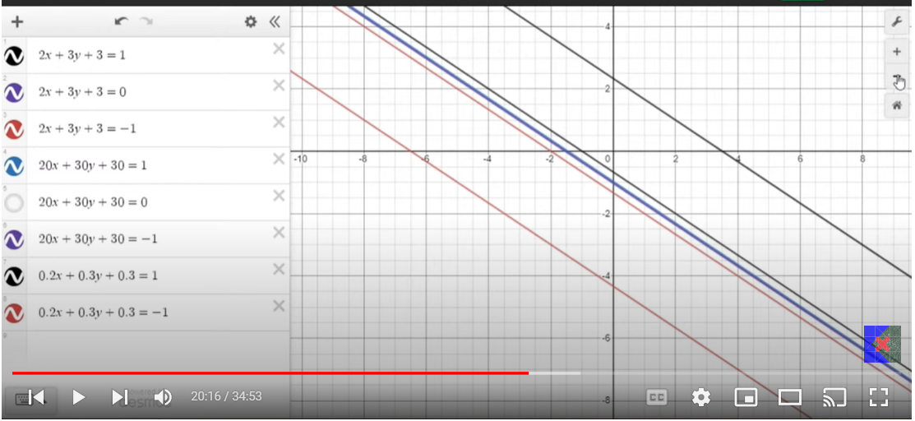

We can observe that changing the coefficients doesn’t make difference on the hyperplane but increasing the coefficients (greater than 1) shifts the hyperplane boundary closer and decreasing coefficients (lesser than 1) shifts the hyperplane boundary way far

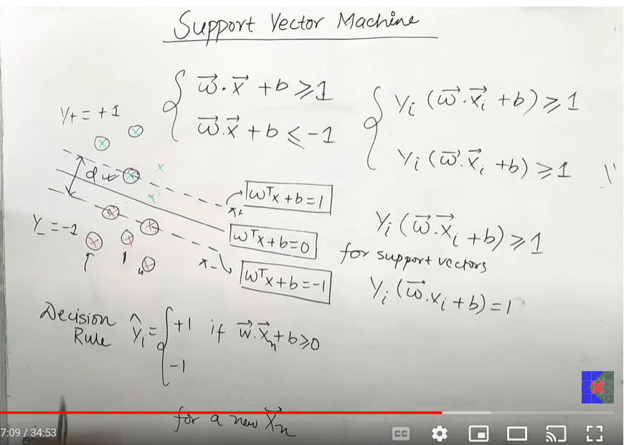

Now we need to maximize the distance d, providing all the existing points are on their same place.

So, we define a constraint that the existing point should follow wx +b >=1 and wx + b <= 1. Such that all the points are either less than or greater than decision hyperplanes and some of the points are exactly on the line (support vectors)

We can generalize both the equation into a single equation by multiplying it with respective y values (- 1 and 1) and we get the same equation

Y(wx+b)>=1, which is y(wx+b)=1 for the support vectors

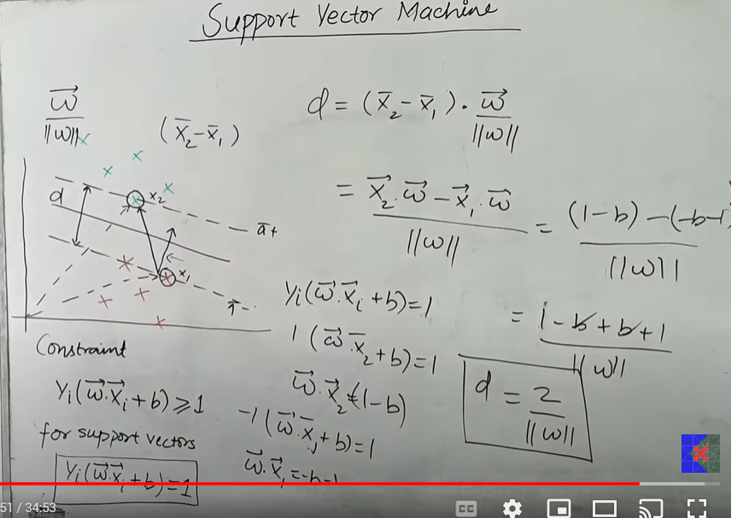

Now to calculate the distance d, we find the distance b/w x1 and x2 and project it on the vector which is perpendicular to x1. So in essence, we need to dot product (x2-x1) and unit vector of w(which is perpendicular to x)

We calculate the value of x2w and x1w from the equation y(wx+b) =1

And we get value of d as 2/ |w|

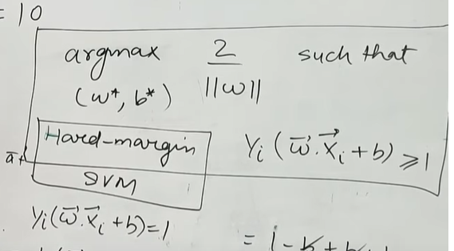

This will only work if the data is perfectly within the boundary with no noise (y(wixi + b ) > 1), This is known as hard margin SVM

# Mathematics of Support Vector Machine | Soft Margin SVM

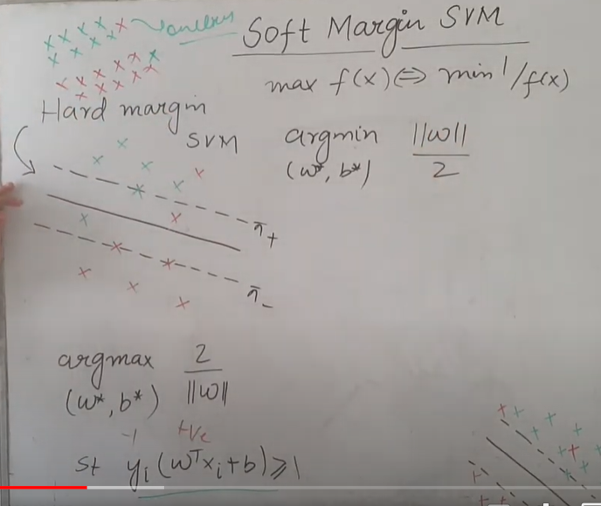

So, practically hard margin SVM isn’t possible as we won’t find any dataset that would be perfectly linearly separable. So the constraint y(wx+b) will fail. There will be some positive points that would be in negative section and some negative points in positive section

To counter this problem, we use soft margin SVM

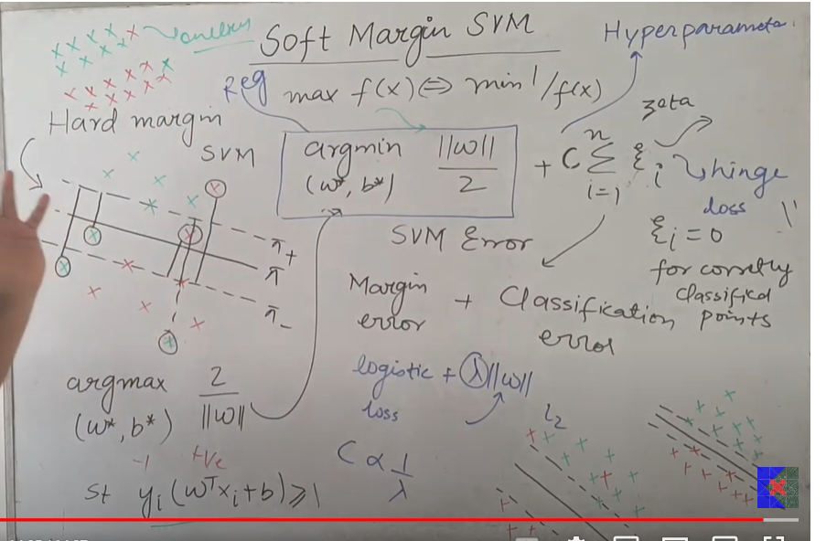

Soft margin SVM loss function comprises of two terms One is Margin error or regularization term which is responsible to increase the boundary b/w pi+ and pi-. It is similar to hard SVM. Other term is the hinge loss or Classification error term which is responsible to minimize the misclassified points and the points lying in other boundary. It is calculated by distance of misclassified from its correct plane. For eg if negative point is lying in positive end then distance from negative hyperplane to point is the residual.

Our aim is to minimize both hinge loss and margin error and then find w and b for it. However, we have a hyperparameter (c) which controls which error we want to reduce more. If c is more then we are focusing on reducing the misclassified points and if we are reducing c then we are trying to focus on handling margin error.

Our aim is to find optimized value for c. c is inversely proportional to lambda from linear regression

# Kernel Trick in SVM | Geometric Intuition

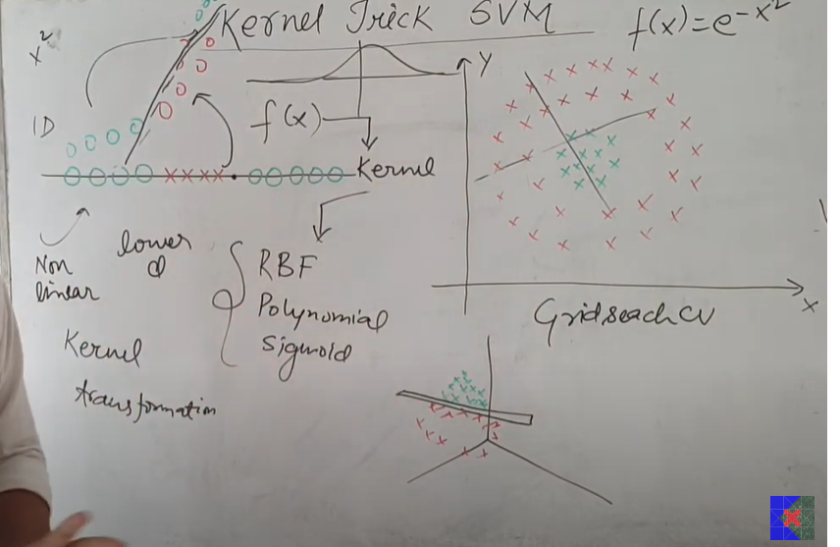

In kernel trick, we convert 1-D linear inseparable data to 2-d or 3-d separable data by applying kernel transformation (RBF, polynomial and Sigmoid) which is an mathematical function. It help us to separate the classes in higher dimension

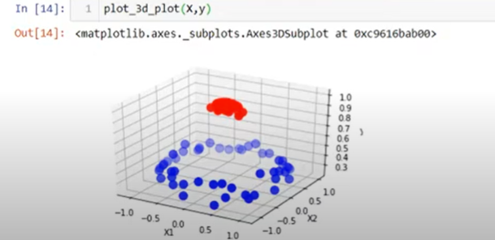

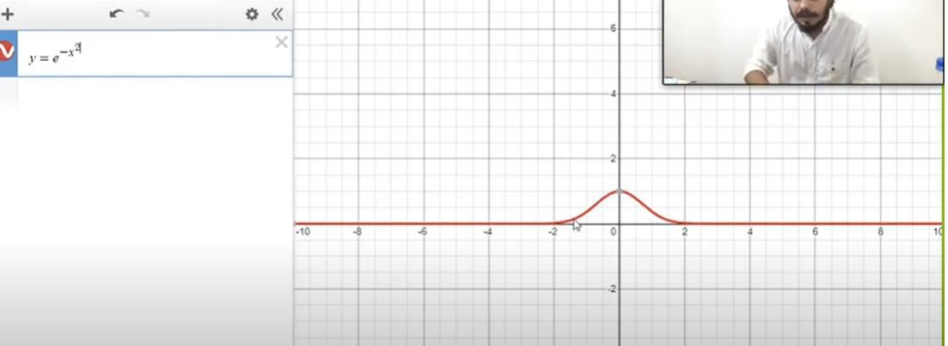

We applied radial function which will elevate the in between classes and hence we can segregate two different classes

# Gradient Boosting | How Gradient Boosting works?